Neural Network representation project

Week 1

- learned and understood of Machine Learning, Neural networks and back propagation algorithm.
- Created a basic implementation of back propagation algorithm on python using only numpy. Algorithm was implemented on a housing problem with 3 features. The network consisted of 3 layers namely – 1 Input layer, 1 Hidden layer and 1 Output layer. Input layer has 3 nodes, Hidden layer has 3 nodes and output layer has 1 node. Sigmoid Activation function was used. Accuracy was 99.997%.
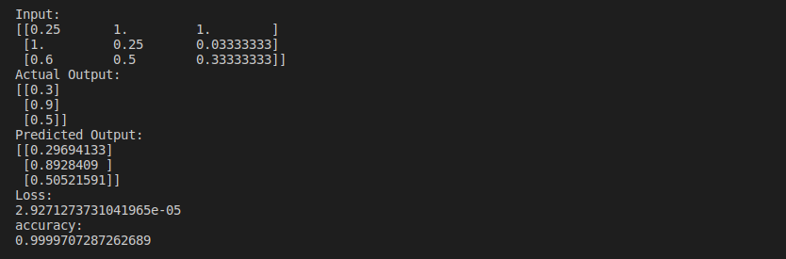
- Created a similar Neural network as before using TensorFlow for training MNIST data set. The neural network consisted of 3 hidden layers. Each layer had 100 nodes. The Activation function used was Relu and the optimizer used was Adamoptimizer. The Accuracy was around 90%.

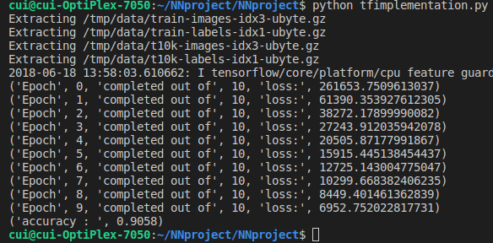

Week 2

